Online Bulletin Board User Guide

(Administrator)

To access the system type or copy this url in the web browser: <url here>

1. **Login**

To access the system, enter these:

Username: <uname>

Password: <pass>

Then click the Login button.

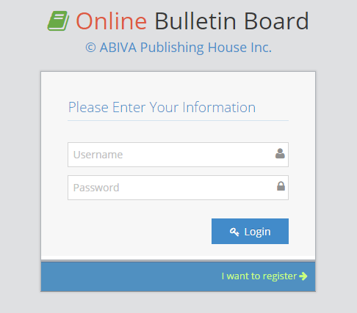

If you have provided the correct username and password, you will be redirected to the index page of the system. Otherwise you will be prompted with this dialog box:

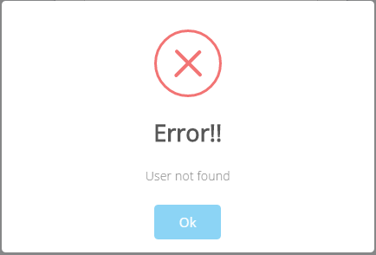

1. **Index Page and Menu**

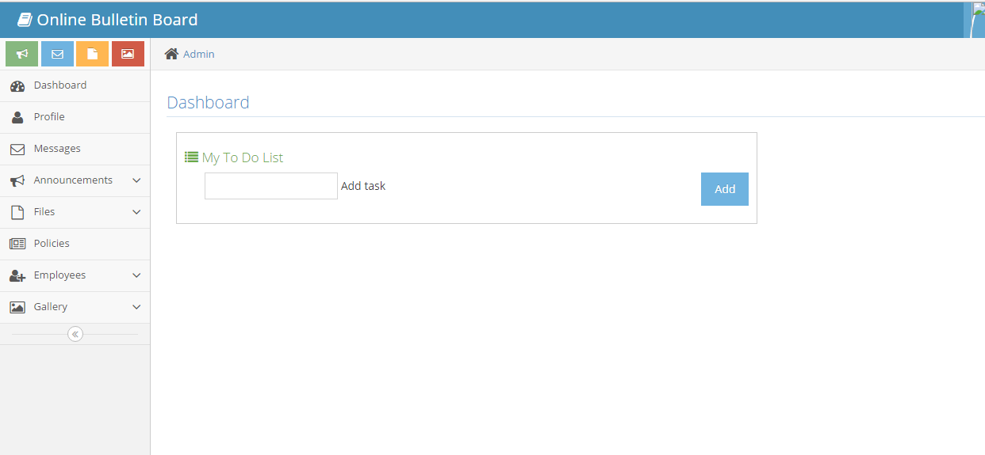

This is the index page in which the user will be redirected to after logging in. You can also see the side menu which will help you in navigating the system.

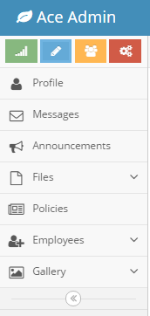

The index page provides a to do list. To use this, input any text in the Add Task field then click the Add button.

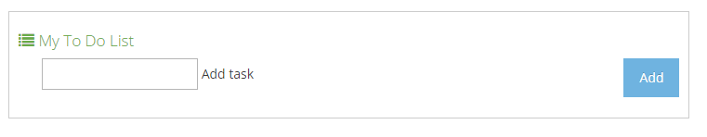

The task you’ve entered will be enumerated in a list.

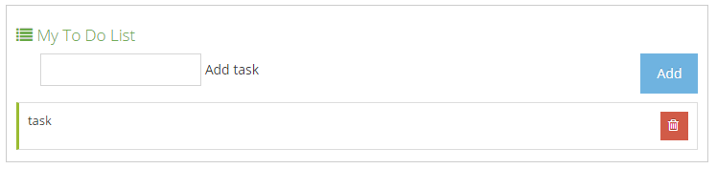

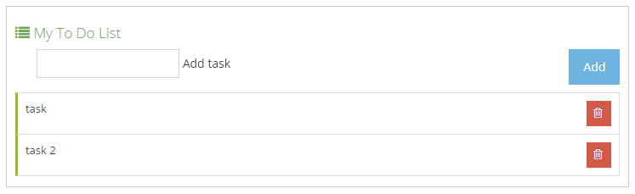

To mark a task as finished, click its row once. Click it again to remove the mark.

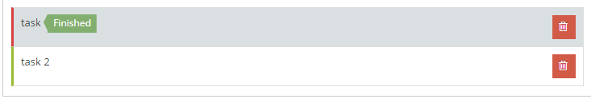

Click the button to delete a task.

1. **Profile**

Click the button

You will be redirected to the User Profile Page. You can see the details you have registered.

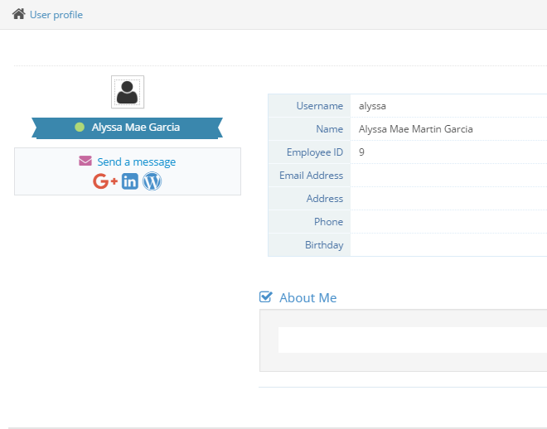

You are able to fill out the blank fields in the form by clicking the button found at the upper right corner of your screen.

After clicking the Edit Profile button, you will are now able to fill out and provide additional details to your profile.

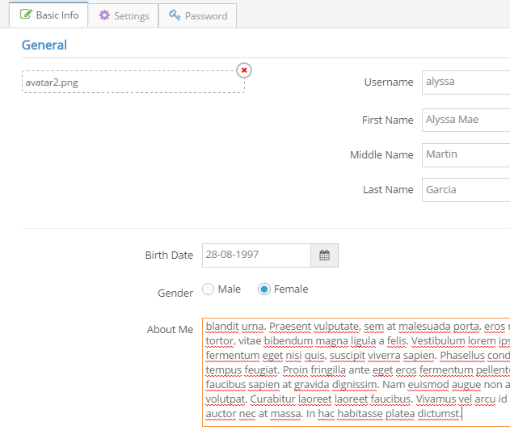

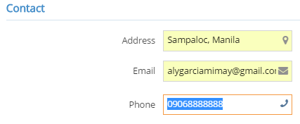

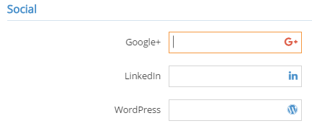

To change your profile picture, click this:

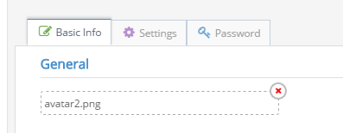

The file chooser will show, then choose your profile picture.

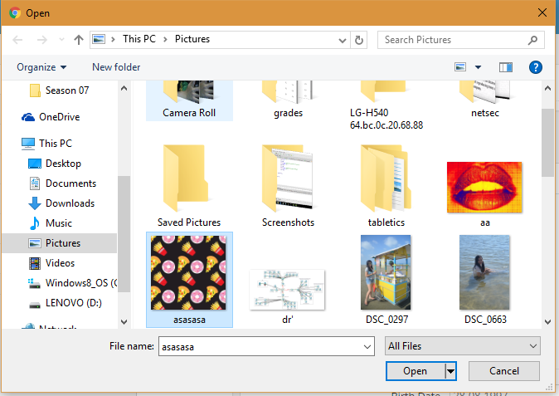

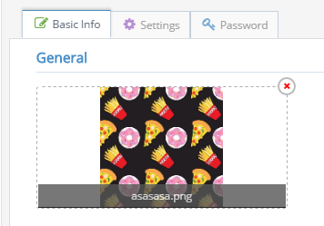

Click the  button at the bottom part of the form to save your information.

After saving, you can now see you updated user profile.

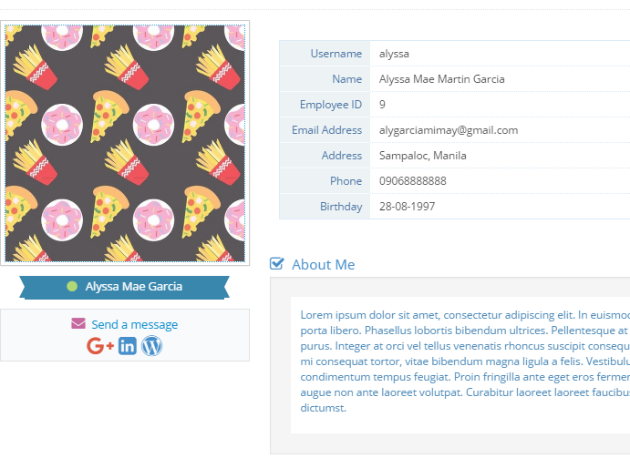

1. **Change Password**

Click  then click the Password tab that can be seen at the top panel of the form.



This will then show this form:

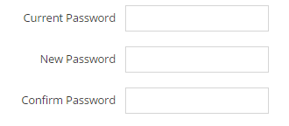

To change password, enter your current password then enter your new password. If you have successfully changed your password, you will see this:

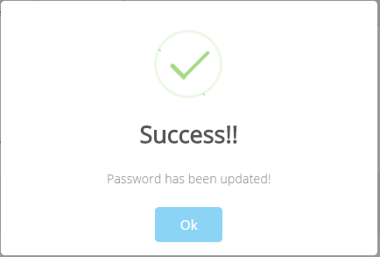

Otherwise, you will be prompted with this:

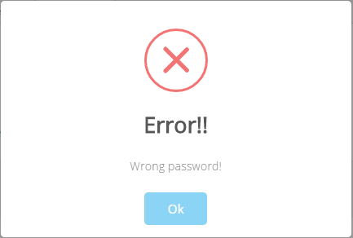

Your old password cannot be the same as your new password.

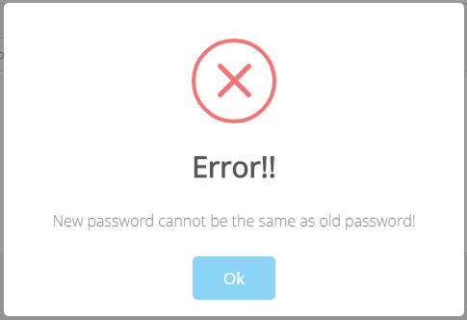

1. **Employee Management**

Click the Employees tab on the side menu. Then click Add Employees.

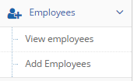

You will be redirected to a form which enables you to register new users.

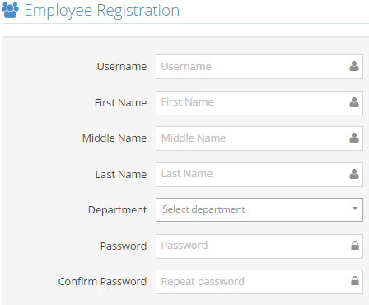

Fill out all of the input fields in the form then click the button found at the bottom of the form. If you have successfully registered a new user, the system will redirect you to  tab.

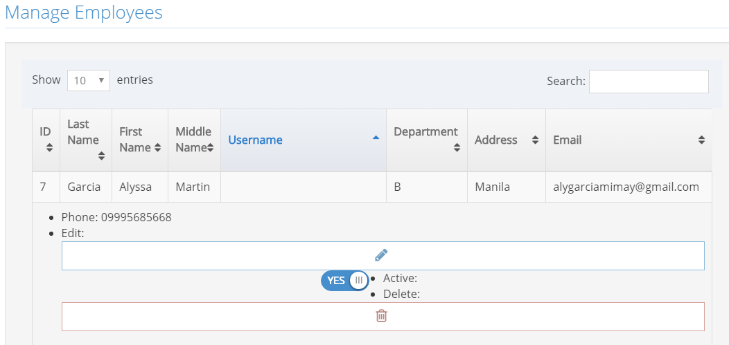The  tab shows you all of the information of all employees registered in the system. This tab enables you to edit an employee’s details, and delete an employee.

All of the information will be shown in a table. To edit an employee’s info, click the  button found at the Edit column of the table.

Note: When the screen is maximized, the table may not show all of its columns. To view the missing columns, click the ID of the row you want to edit. This applies to all tables available in the system

Clicking the button will trigger the system to show a form.

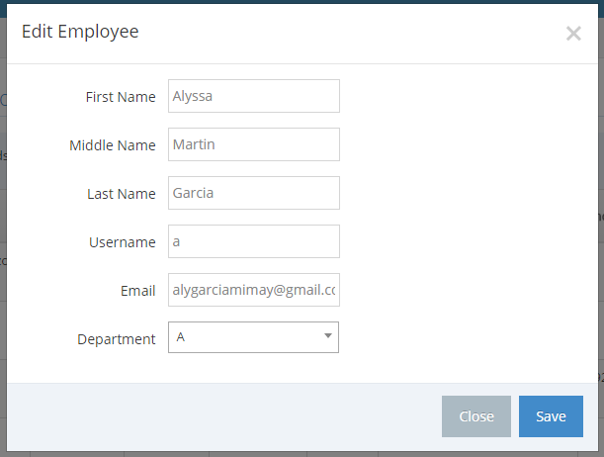

Click the Save button to save your changes.

To delete an employee, click the  button found at the Delete column of the table. A dialog box will then show for confirmation.

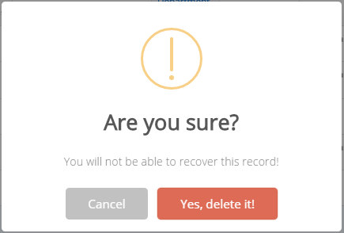

Another dialog box will prompt if you have successfully deleted the employee

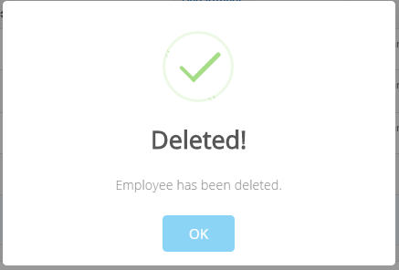

1. **Import Employees**

Click the Add Employees tab



To import employees, look for the dropzone titled Import users beside the Add employee form.

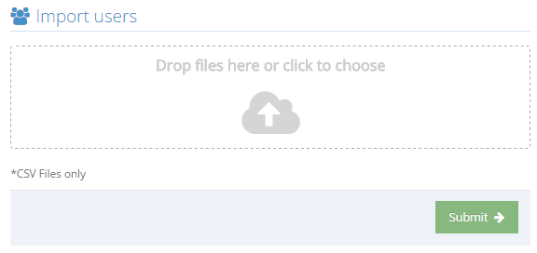

Click the dropzone area and choose a .csv file to import employees. This form only accepts .csv files.

The content/employees listed in the .csv file will be imported to the system after clicking the button.

Go to the View employees tab to see the data you have added.

1. **Gallery**

Click the Gallery tab from the side menu then click Upload pictures.

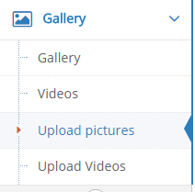

The system will redirect you to the uploading page.

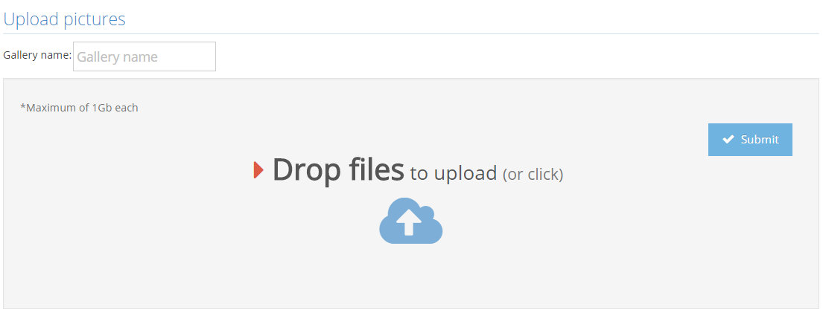

Provide a gallery name

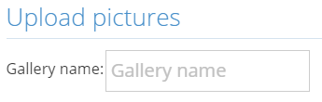

And then click the dropzone area, this will show the file chooser. Drag and drop files to the area, or simply click the files. Only files with .jpg,.jpeg,.png and .gif extensions are accepted with the max size of 1Gb each picture.



Click the  button. The speed of the uploading of pictures depends on the file size and the number of pictures being uploaded simultaneously.

You will then be redirected to the album you have created.

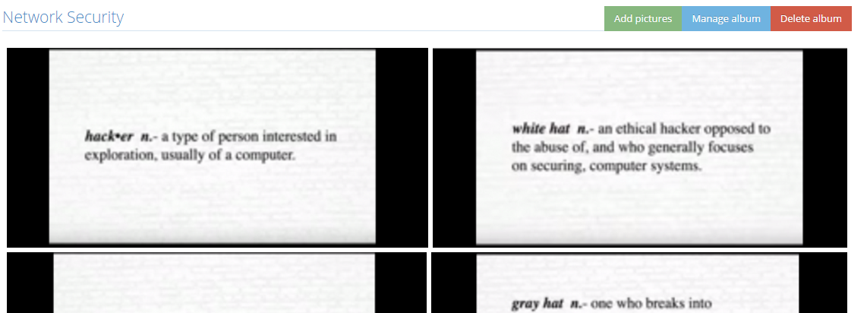

Click a picture to view

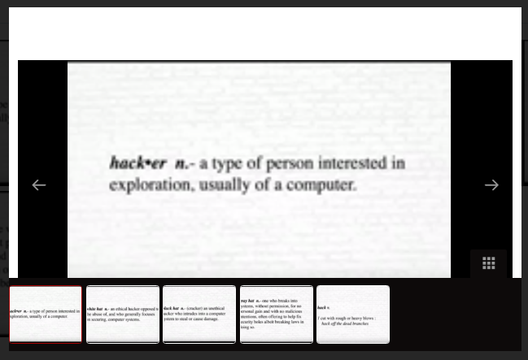

You will see three buttons available at the top-right part of the page.



Click Add Pictures if you want to add more pictures in your album.

Click Manage album to delete photos individually or delete selected photos.

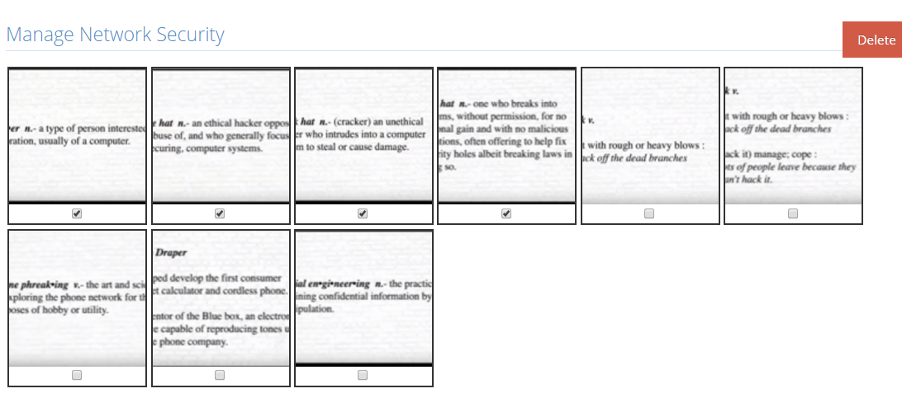

Click Delete Album to delete the album including the pictures.

To upload videos, click Upload videos.



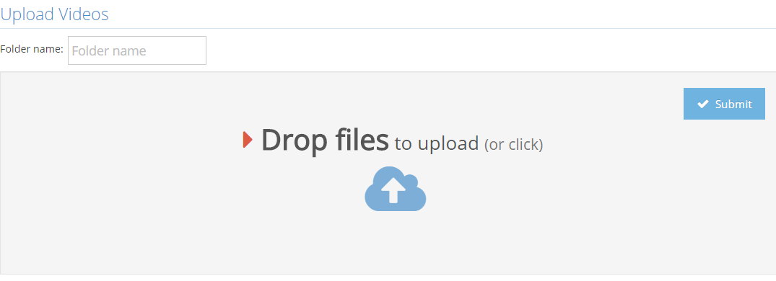

Upload videos by clicking the dropzone and then select the videos to be uploaded. Any video file is accepted with the max size of 1Gb each video.

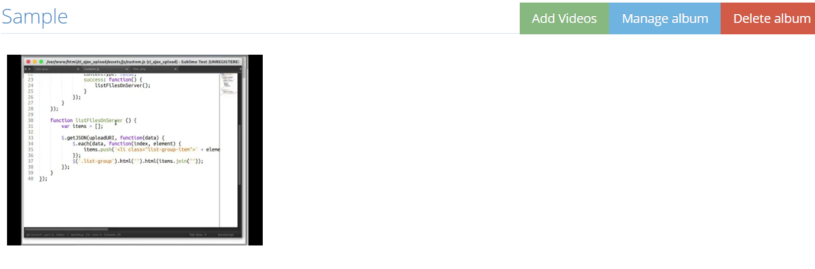

Click the video to play it.

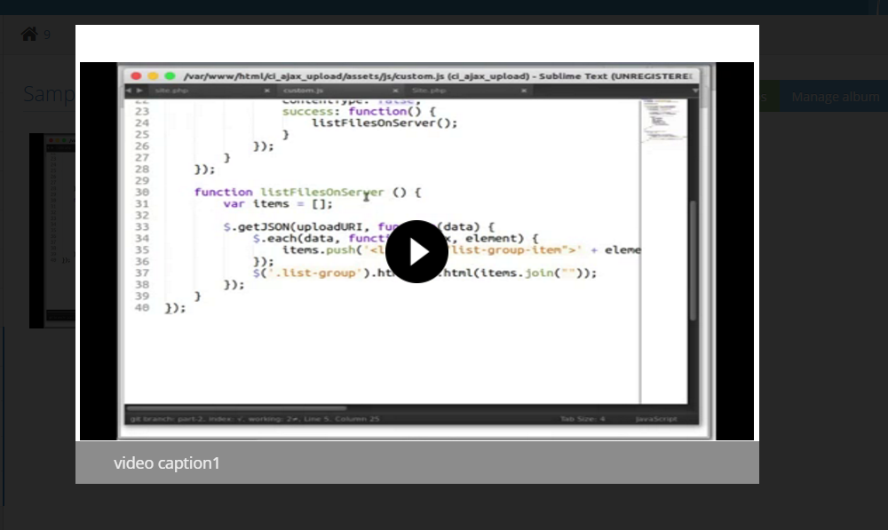

These three buttons are seen when viewing a video album:



Click Add Videos to add more videos in the album.

Click Manage Album to delete selected videos.

Click Delete album to delete the album including its contents.

1. **Announcements**

Click the Announcements tab then click Create and Manage. This will redirect you to the Announcements page.

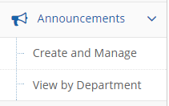

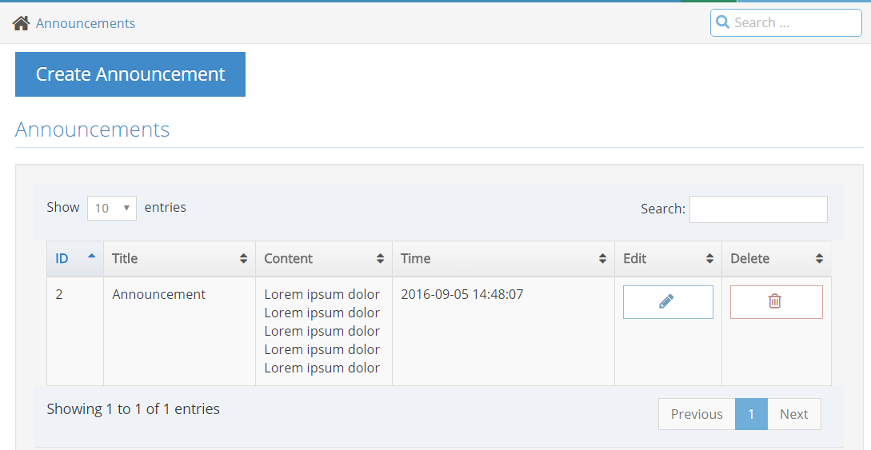

Click the  to post a new announcement. This will then trigger a form.

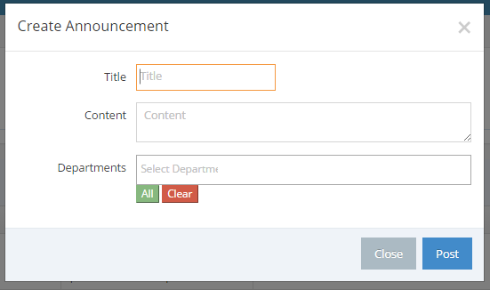

Provide a title, content, and select all of the departments that can access the announcement.

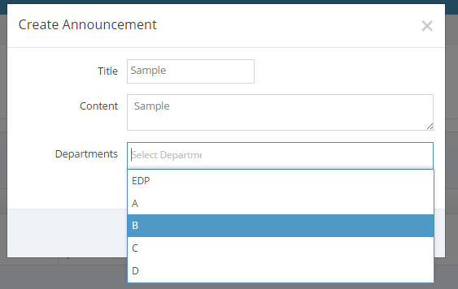

Or click the ALL button to select all departments

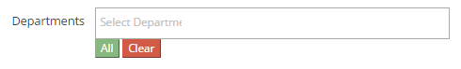

Click the  button at the bottom right part of the form to post the announcement.

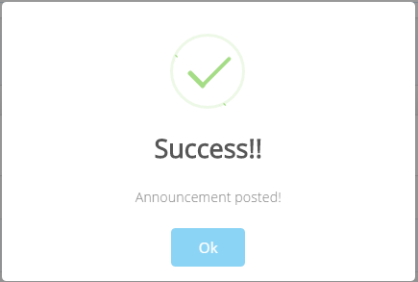

You will see the announcement added to the table of announcements.

To edit an announcement, click the  button found at the Edit column of the table. Clicking this will trigger a form that enables you to edit the announcement you have selected.

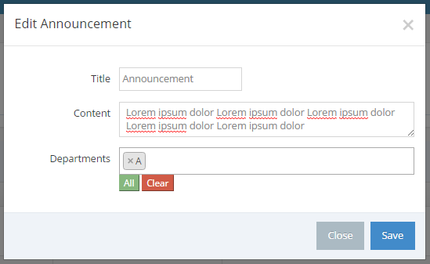

Click the SAVE button to save changes.

To delete an announcement, click thebutton that can be found at the Delete column of the table. Clicking this will show a dialog box that asks for confirmation.

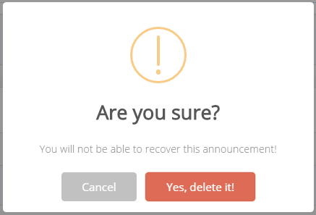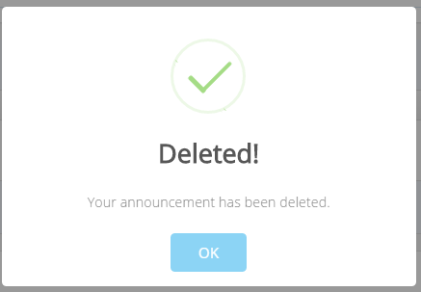

To view the announcements by department, Click View by Department



Clicking this will redirect you to this page:

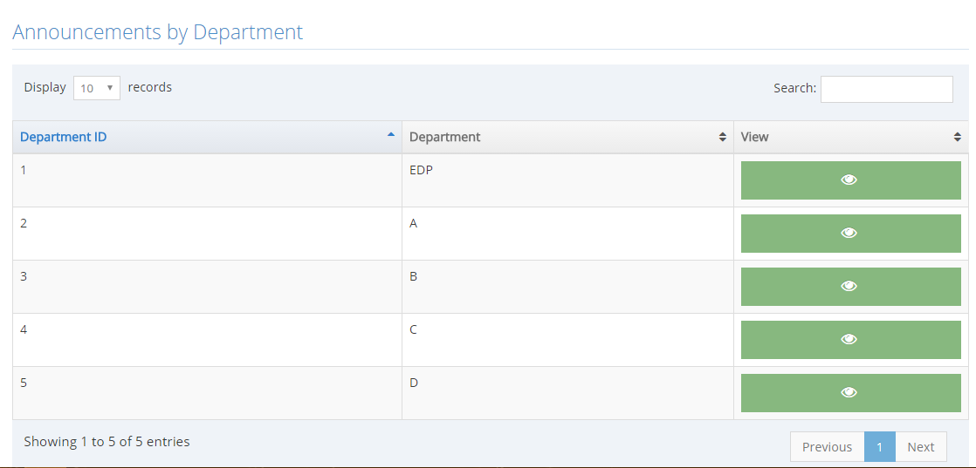

Click the button to view all of the announcements in a specific department.

1. **Files**

Click the Files tab found in the side menu then click Upload files.

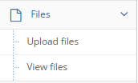

This will then redirect you to the Upload files page.

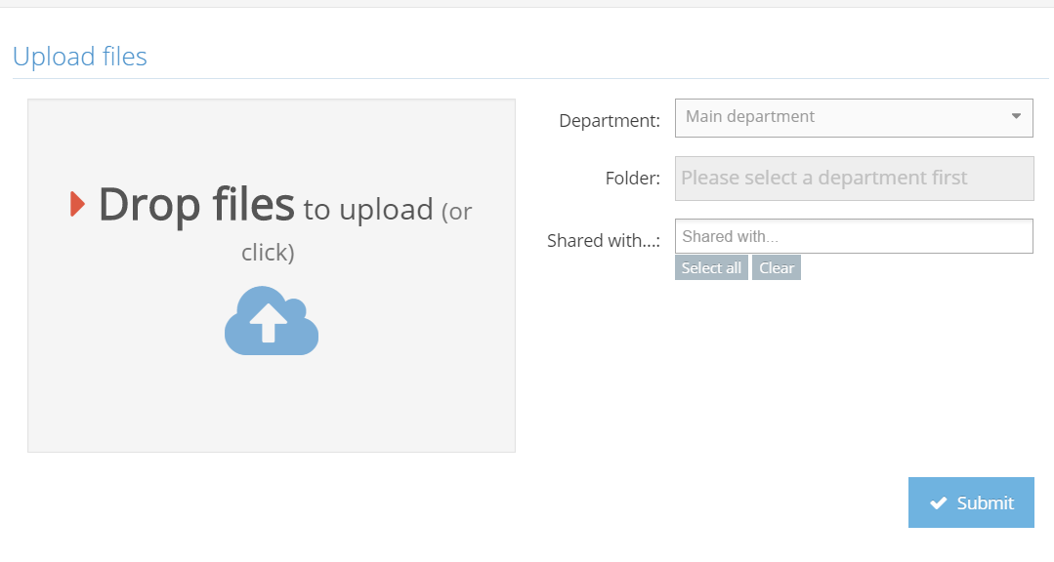

Choose a department, provide a folder name, and choose the other departments that can access the folder. Click the dropzone area, choose files you want to upload then click the submit button. Any image files and files with .docx,.doc,.ppt,.pdf,.txt,.xls,.xlsx,.rar,.zip,.7z extensions are accepted with the max size of 1Gb each file.

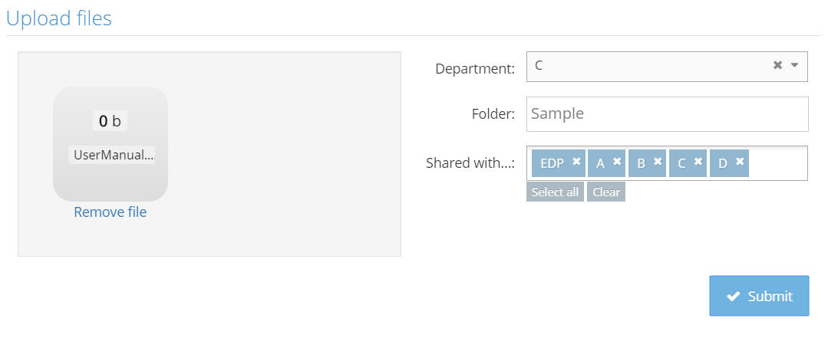

You will be redirected to a page in which the folders of each department is shown in a table.

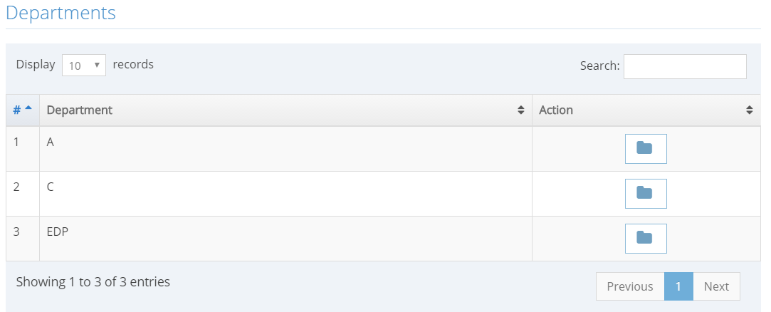

Click the  button at the Action column of the table. This will enable you to view the folders under the department.

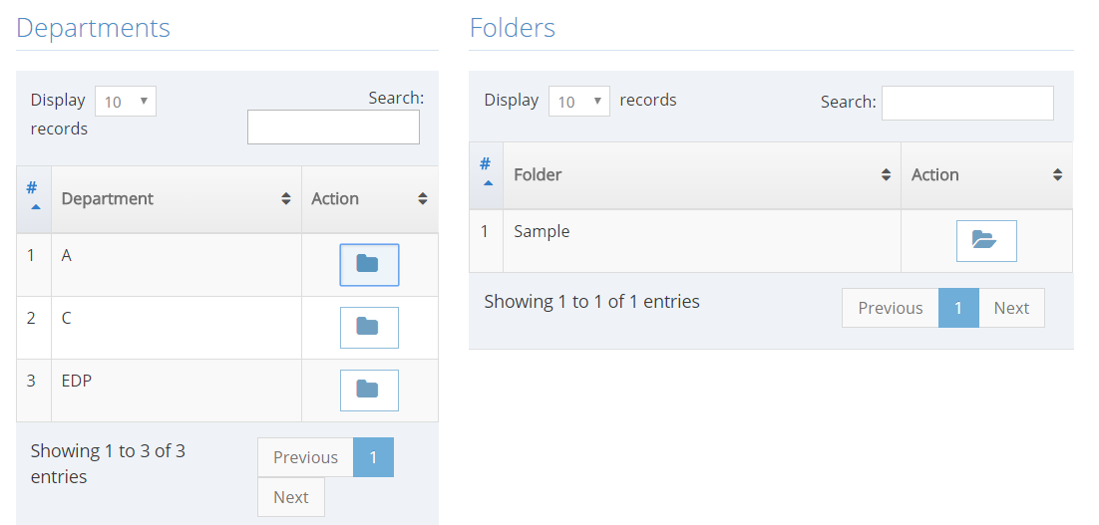

Click the  button found at the Folders table. This enables you to view all of the files uploaded in this folder.

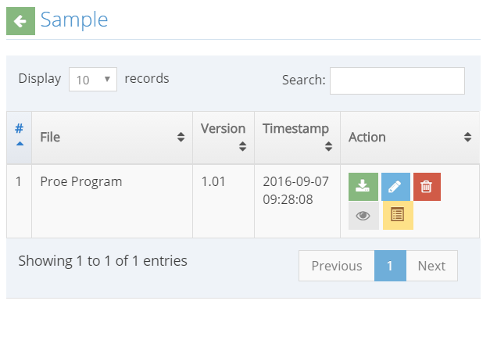

 This button enables you to download the file

 This button deletes the file

 This button lets you view the file. (Not working)

This button triggers a form that enables you to edit the file.

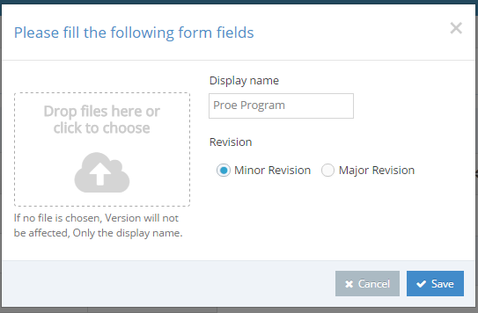

This form lets you upload a new file, input a display name, and choose if the revision made is minor or major.

A minor revision adds a .01 to the current version of your file, while a major revision adds 1 and drops the decimal values.

Ex: File version 1.15 will be file version 2.0 after a major revision.

Click the Save button to save the new version of the file.

You will now see the new version of the file.

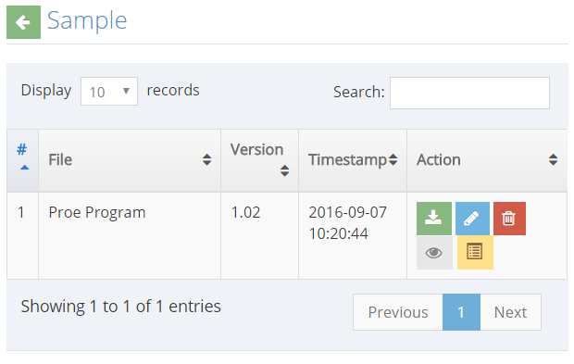

Click the button to view the Archives. This lets you see all of the older versions of the file uploaded in the system.

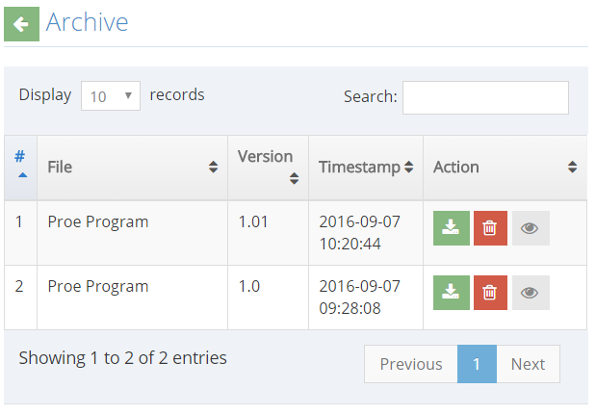

1. **Policies**

Click the  tab found in the side menu. This will redirect you to the Policies page.

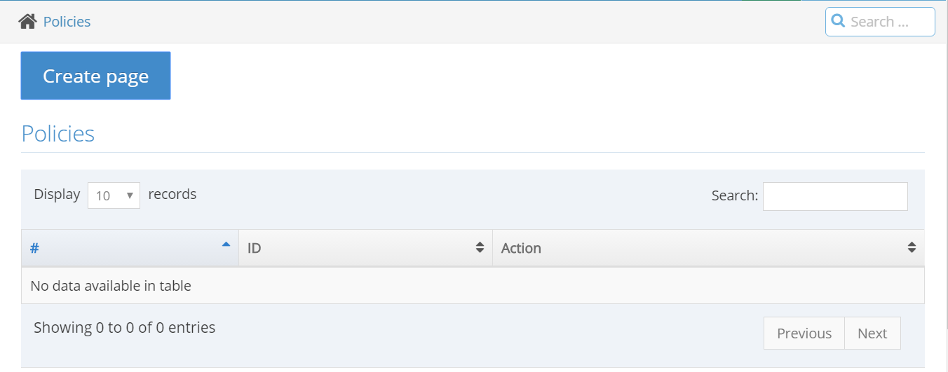

Click the 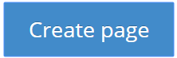 button. This will trigger a form:

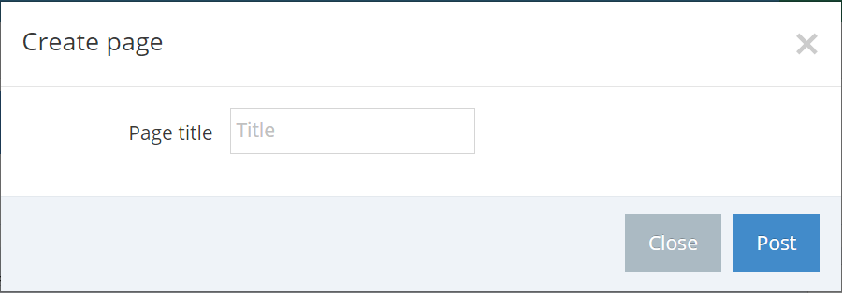

Provide a page title and click the Post button.

After clicking the Post button, the system will redirect you to a page with a text editor.

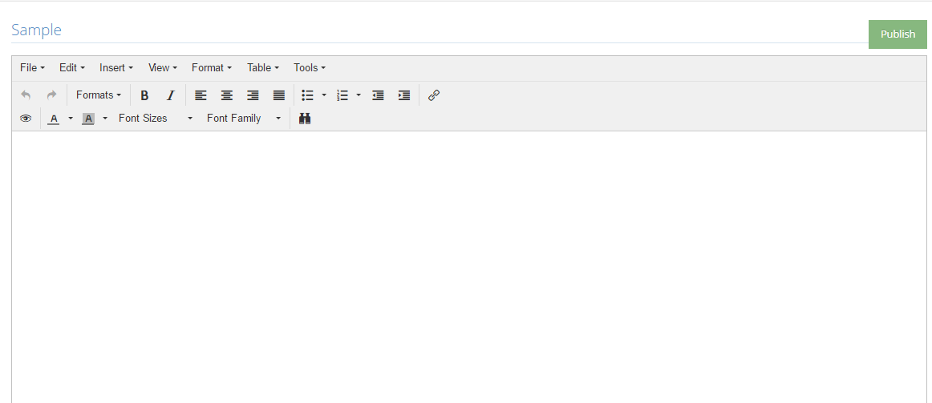

You can paste any text and use the tools provided in the page.

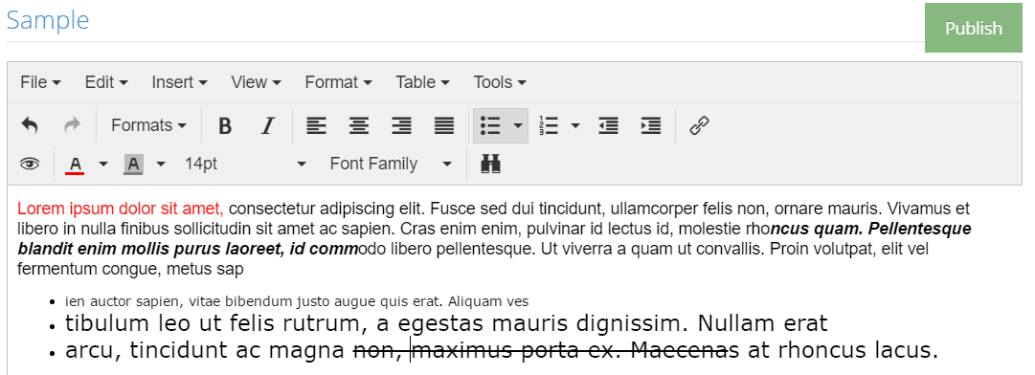

Click the  button to publish the document.

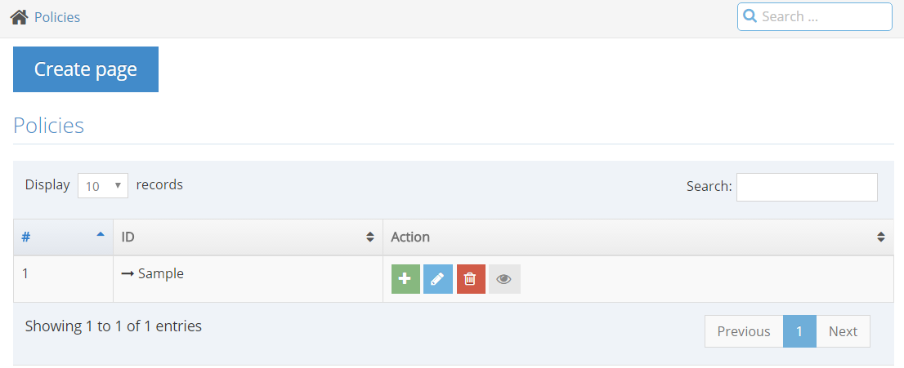

You can now see your published page in the table located at the Policies page.

Click the button to add a sub-page to the previously published page. This will also trigger a form asking for a page title.

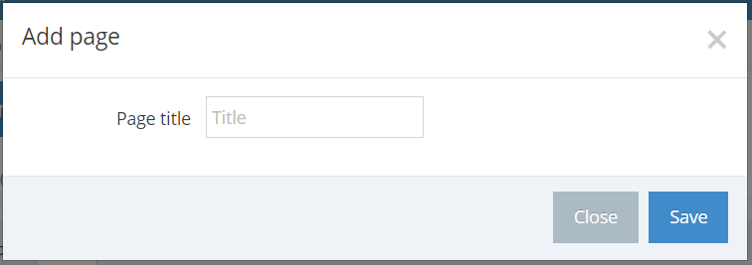

Provide a page title, click the Save button. After clicking the Save button, the system will redirect you to a page with a text editor. Fill the text area with text and click the Publish button. Your table will look like this after clicking the Publish button:

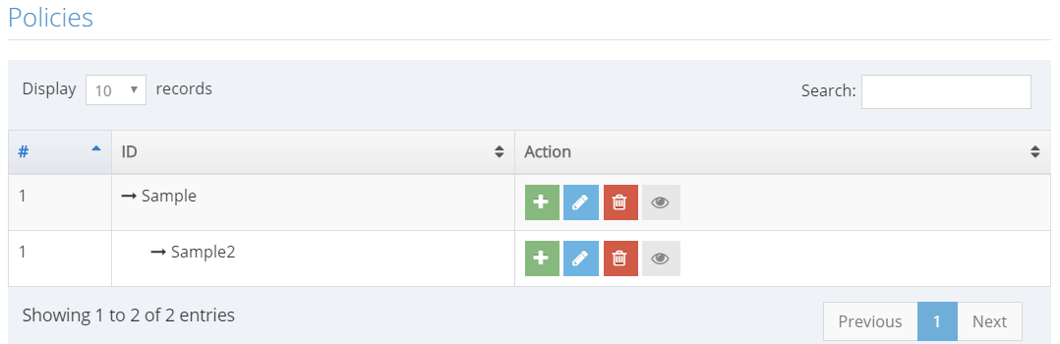

To add a new page (not a sub-page), click  again.

The  button enables you to edit the document published. This will redirect you again to the text editor.

The button let you delete the page. (not working)

The  button lets you view the document in a web page, not in a text editor:

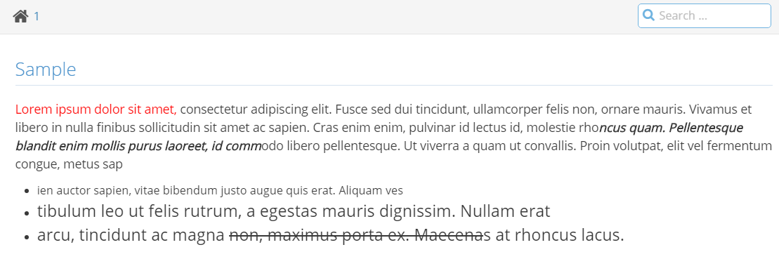

1. **Logout**

To log out, click  that can be found at the upper right corner of your screen. This will show a dropdown menu. Click the logout button and then you will be redirected to the login page.

